|  |  |
| --- | --- |
| LAB # 2 | |
| **Finding out roots of an equation using Bisection Method** | |
| Student Name: | Kamil Rasheed Siddiqui |
| Registration Number: | ME201024 |
| Semester: | 5 |
| Group: | A |
| Date of Submission: | November 11, 2022 |
|  |  |

**Problem Statement:**

**Determine the real root of f (x) = -26 + 85x - 91x^2 + 44x^3 – 8x^4 + x^5 using bisection method to locate the root. Employ initial guesses of x_i = 0.5 and x_u = 1.0 and iterate until the estimated error falls below a level of error = 10%.**

**Program Code:**

|  |
| --- |
| clear, clc  %% Defining Equation  f = @(x) - 26 + 85*x - 91*x^2 + 44*x^3 - 8*x^4 + x^5    x_i = 0.5;  x_u = 1.0;  n = 5;  e = 0.1;    if f(x_i)*f(x_u) < 0  for i = 1:n  x_r = (x_i + x_u)/2;  fprintf('P%d = %.4f ; f(x) = %.4f \n', i, x_r, f(x_r));  if abs((x_r-x_u)/x_r) < e || abs((x_r-x_i)/x_r) < e  break  end  if f(x_i)*f(x_r) < 0  x_u = x_r;  elseif f(x_u)*f(x_r) < 0  x_i = x_r;  end  end  else  disp('No roots between the limits')  end    %% Plotting    temp_x = -2:0.01:3;  for i = 1:length(temp_x)  y(i) = f(temp_x(i));  end    plot(temp_x,y, 'r--'); hold on;  plot(x_r,f(x_r)); hold on;  line([-2 3], [0 0]), line([0 0], [-1200 200])  xlabel('X Axis')  ylabel('Y Axis')  title('Kamil Siddiqui - Root Finding Using Bisection Method Lab3') |

**Results:**

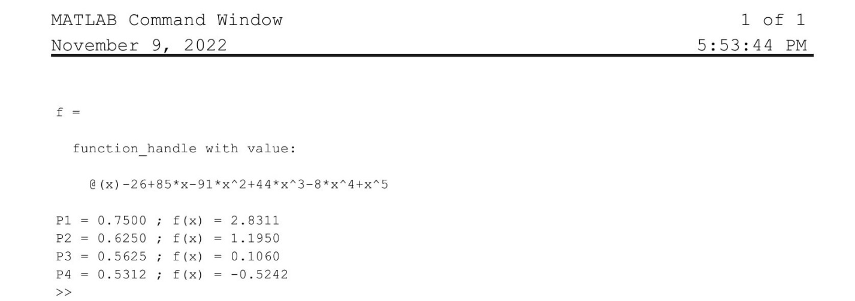

**Graphical Result:**

